How I launched 40 quests resulting in 111K activations
In Web3, attention is easy to buy. Adoption is not.
Quests close that gap. They turn “I heard about this protocol” into a guided set of actions that prove usage, validate completion, and reward the right behavior.
Towards the end of last year, I launched 40+ quests across major platforms, resulting in 111K+ unique activations. The work was built as a repeatable system, where each quest is treated like a mini product launch.

Overview
- What Are Quests - What it is
  - On and Off-chain

- Why Quests Matter - To who and why it matters
  - Users, Projects, Quest Platforms, and Me

- How I build quests
  - Project Discovery - Strong fit shortlist - Meaningful first use
  - Project Enrichment - Full research pack - Test like a user
  - Referral Setup - Trackable referral link - Verify with second wallet
  - Functional Testing - Confirmed working flow - Minimum viable transaction
  - Quest Doc Build - Clear card-by-card steps - Zero ambiguity wording
  - Preview Image - Consistent quest creative - Clean template system
  - Builder Implementation - Verified tasks live - Chain and contract checks
  - Review and Approval - Quest goes live - Fast feedback loop
  - Promotion - Distribution in community - High-intent visibility

Resources:
Many resources were generated for the purposes of:
- Project Discovery - Find projects to create quests
- Quest Enrichment - Research the project and find links and information
- Quest Building - Setup the first draft, use the quest builder, and get the quest reviewed
- Quest Promotion - After publishing the quest, promoting the quest for user adoption

All Quest Resources - All Quest Portfolio Resources
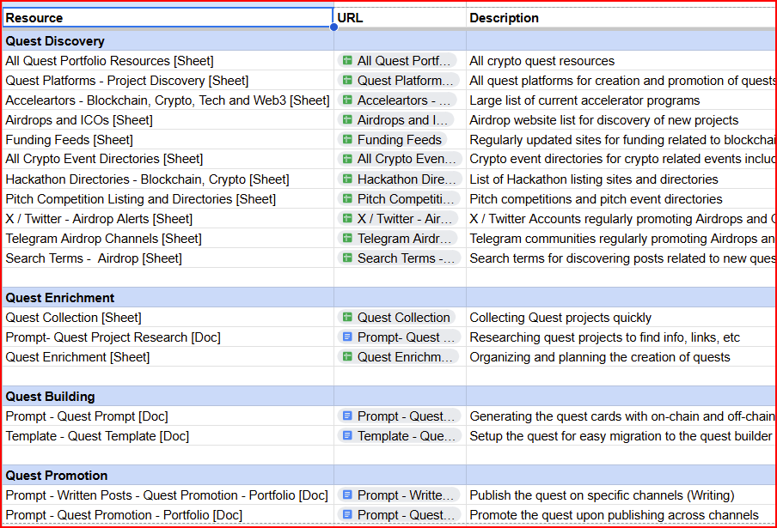

What Are Quests?
A quest is an interactive onboarding and growth campaign that blends on-chain actions, offchain actions, and verification with rewards.

Think of it as a structured user journey.

Instead of asking someone to “go try the product,” you give them a clear path to the first meaningful outcome.

Quest Journey Overview:
- A user opens the quest
- User completes actions
  - On-chain - Swap, Deposit, Provide liquidity, Stake, Lend, Borrow, Bridge, Mint, Vote, etc
Example - Layer3
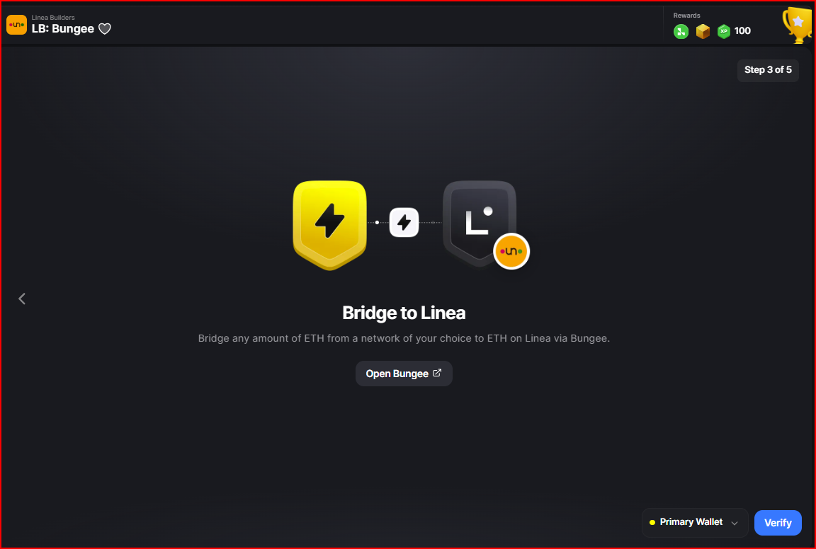

  - Off-chain - Open Link, (Go to website, Read docs, Watch a tutorial, etc), Complete a quiz, follow on social media, join community (discord or telegram), Engage with campaign posts, Contribute on GitHub, etc
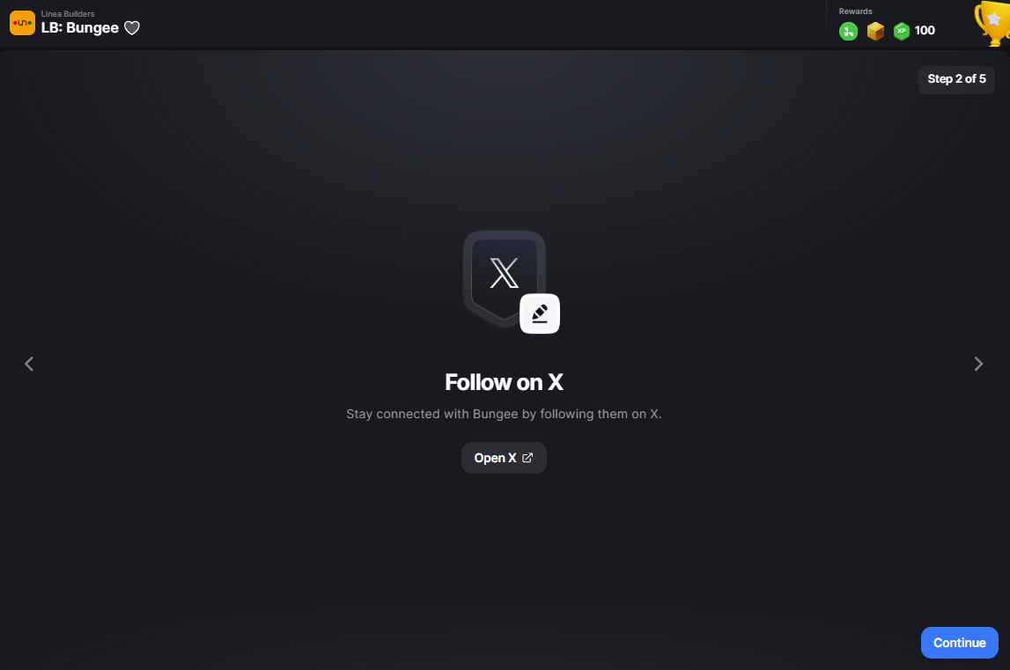

- Rewards unlock upon completion
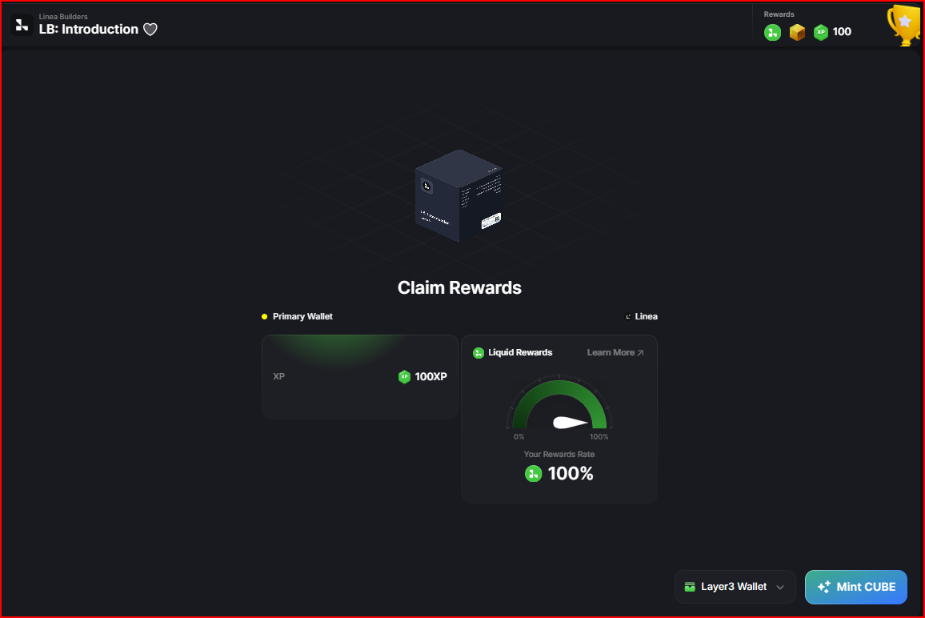

There are many different quest platforms, here are just a few:
Quest Platforms - Project Discovery
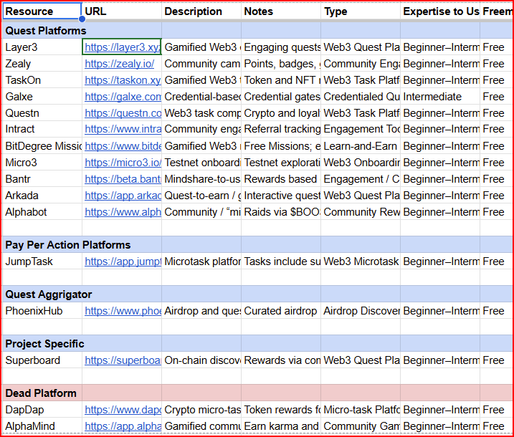

Why Quests Matter

Why Users LOVE Quests
Quests reduce confusion and increase confidence.
- Learn by doing - Better appreciate of crypto via exposure to new projects
- Faster first success - a guided on-chain experience
- Less fear of mistakes - Genuine projects with real rewards
- Progress feels measurable - Each quest is gamified
- Reputation becomes portable - Show your score and get into the community

Why Projects LOVE Quests
Quests are a performance channel built around outcomes.
Instead of optimizing for impressions, teams can optimize for verifiable actions: first swap, first deposit, first vote, first bridge.
- Higher intent users - Real users using real liquidity
- Faster time to activation - Quest promotions = Fast turnaround time
- Guided “aha” moments - Provide genuine experiences and favorite tools
- Cleaner attribution signals - Referral URLs, UTM links, and traffic spikes for quests
- Better lifecycle sequencing - Create campaigns which have increased on-chain activity
- Community flywheel effects - Introduce users to more of your project, community, and future roadmap

Why Quest Platforms LOVE Quests
Platforms provide the rails that make quests scalable.
They standardize task formats, verification flows, reward delivery, and discovery. That infrastructure is why quests can function as a reliable growth motion, not just a one-off campaign.
- Task templates at scale - Quest volume = greater predictability and more incentives
- Verification tooling - Consistently validate users and activities
- Reward distribution systems - Create incentives for more activity and increase overall growth
- Leaderboards and sprints - Competition and gamification elements
- Analytics and admin workflows - Incredible granular tracking and testing

Why I LOVE Quests
My motivation is simple: quests are where growth, product, and community meet.
I like work that is measurable, user-first, and hard to fake. Building quests forces precision: every link, instruction, proof, and reward mechanic has to hold up in the real world.
- Adoption focused writing - Practice promotion and “what’s in it for me” writing
- Funnel and UX thinking - Greater appreciation for better user experience and product-led growth
- Proof based growth loops - Clear demonstrations of real-world gamification and user triggers resulting in better conversions
- High standards testing - Set a high bar with consistency
- Clean execution under constraints - Go from manual, To somewhat automation, to 90% automated.
Quest Activations on Layer3: 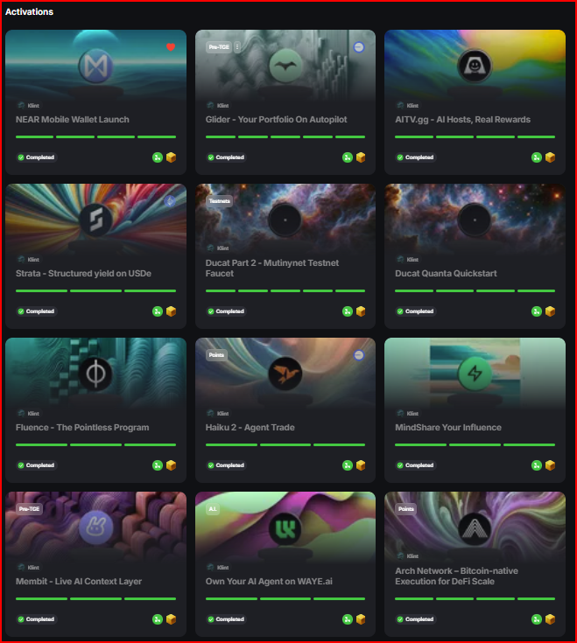

How I Build Quests
Project Discovery Channels:
I source projects where quests can create meaningful first use, not just clicks.

You need to know what you’re looking for, where to find it, and what “good” looks like.

Search Terms:
- Search Terms - Search Terms - Airdrop

Discovery by Channel
- Airdrop and campaign trackers - Web - Airdrops and ICOs Airdrops and ICOs
- Recently funded lists - Funding, Quests, and Discovery
- Accelerator cohorts - Accelerator Programs
- Pitch competition lists - Pitch Competition Listing and Directories
- Crypto Events - All Crypto Event Directories
- Hackathon Directories - Hackathon Directories - Web3, Blockchain, Crypto
- Funding Feeds - Funding Feeds
- Quest Platforms - Quest Platforms - Project Discovery
- Telegram Airdrop - Telegram Airdrop Channels
- X Airdrop Alerts - X / Twitter - Airdrop Alerts

Selection and Prioritization Criteria:
- EVM or Solana Ecosystem - More familiarity and greater adoption
- Functionality - Product works and on-chain activity exists
- Doxxed Founders - Real team with real profiles (Less likely a scam or rug)
- Funding - Did this project get funding - Does the project momentum
- External Audit - Real web audits done by reputable companies
- X Activity - Does this project have genuine and consistent posts on or/ Discord
- Referral Link - Does the this platform allow me to create a referral link and can get credit for referring users
- Smart Contract - Is the smart contract legit - Use de.fi or arkhamintelligence
- Transactions Volume - Are there many transactions (Daily, Weekly, Monthly) associated with the smart contract

Collection:
- Fast Collection - for further review - Quest Collection
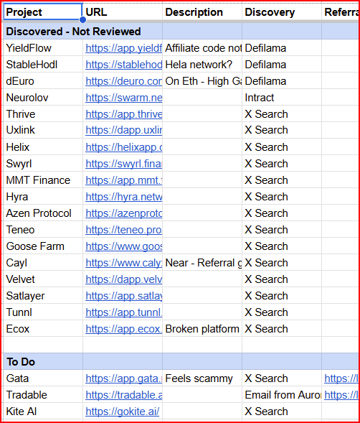

Project Enrichment:
Before writing a single task, I map the protocol like a marketer and test it like a user.
Research checklist:

Web URLs
- Homepage and product pages
- Documentation, litepaper, whitepaper
- Blog, Medium, and News sections

Application / Platform
- Core App URL
- Referral
- On-Chain Actions
Social Media and Community
- X / Twitter
- Discord
- Telegram
- Quest, Airdrop, or Campaign Specific Posts

Resources:
- Deep Research LLM - Perplexity,
- Prompt - Quest Project Research - Prompt- Quest Project Research
- Quest Template - Google Doc - Template - Quest Template
- Quest Enrichment - Add Research to Sheet - Quest Enrichment

Exampe: Using Perplexity to enrich projects
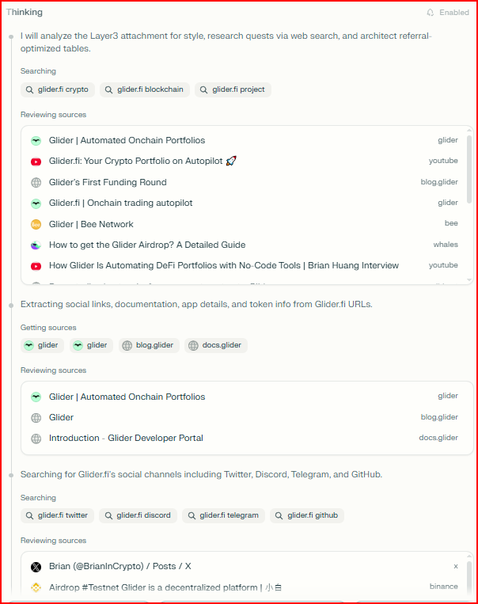

Project Referral Link Creation
If a project has a referral mechanism, I generate a tracking link early.
Referral links give me a chance to earn something on top of the quest.

Referral links create attribution and allow me to track my incentive structure for sustained promotion.

Referral best practices:
- Complete Registration
- Find the Referral Link Generator
- Create / Get Unique Referral LINK
- Test Link (Sign Up with a secondary wallet)
Example - Velvet Trade - https://dapp.velvet.capital/Referral/1
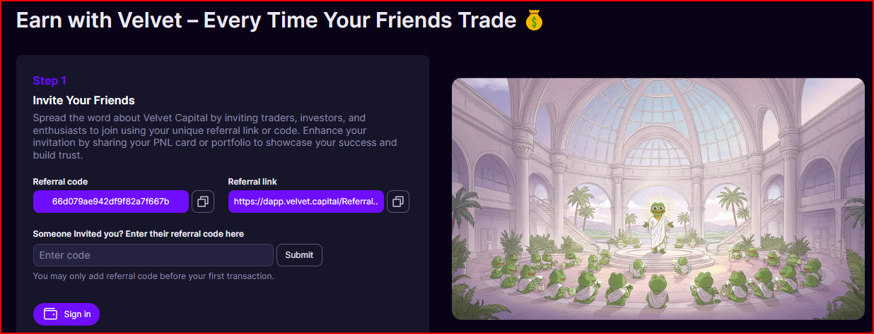

Functional Testing
Testing is where good quests stand out.
I complete every step exactly as a new user would.

Testing standards:
- What actions can be done)
- Does it work (On-Chain)?
- Is it easy (Beginner - Medium)?
- What is the minimum viable transaction
- Confirm positive result (Points or rewards earned)
- Clear time estimates per step

Overview:
Write a few short sentences describing how this was done.

Build the Quest in a Google Doc
In a Google Doc, Build your quest with the following:

Resources:
- Project Links and Raw Data - Quest Enrichment
- LLM + Deep Research / Internet Access
- Prompt - Quest Creation Prompt - Quest Prompt
- Quest Template - Google Doc - Template - Quest Template

Wordsmithing, Adjustments, and Review:
- Protocol Metrics and Details
- Instructions
- Links
- Cards

Most of the time, the LLM (Perplexity), found the web URLs and most of Social Media and community links.

Example
The Autopilot Quest - Draft built in a Google Doc
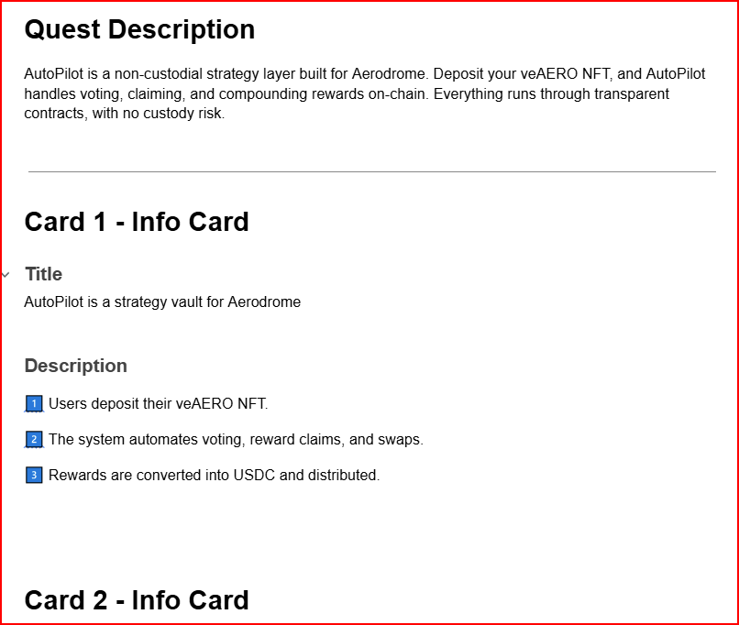

Create the Quest Preview Image
Collect your assets and use a simple template.

Find the logo, make a background, and add it to the template in Photopea.

Tools:
- X / Twitter - Find Logo
- Photopea - Use .PSD template
- LLM + Prompt - Create background photo

Assets:
- Project Logo - Usually found on X / Twitter Profile
- Background - Generate a background (Landscape) using LLM
- Template - .Psd Template
- Photopea - Add Layer Mask over template + Add background

Example - Bless PNG - Bless - quest logo psd.psd
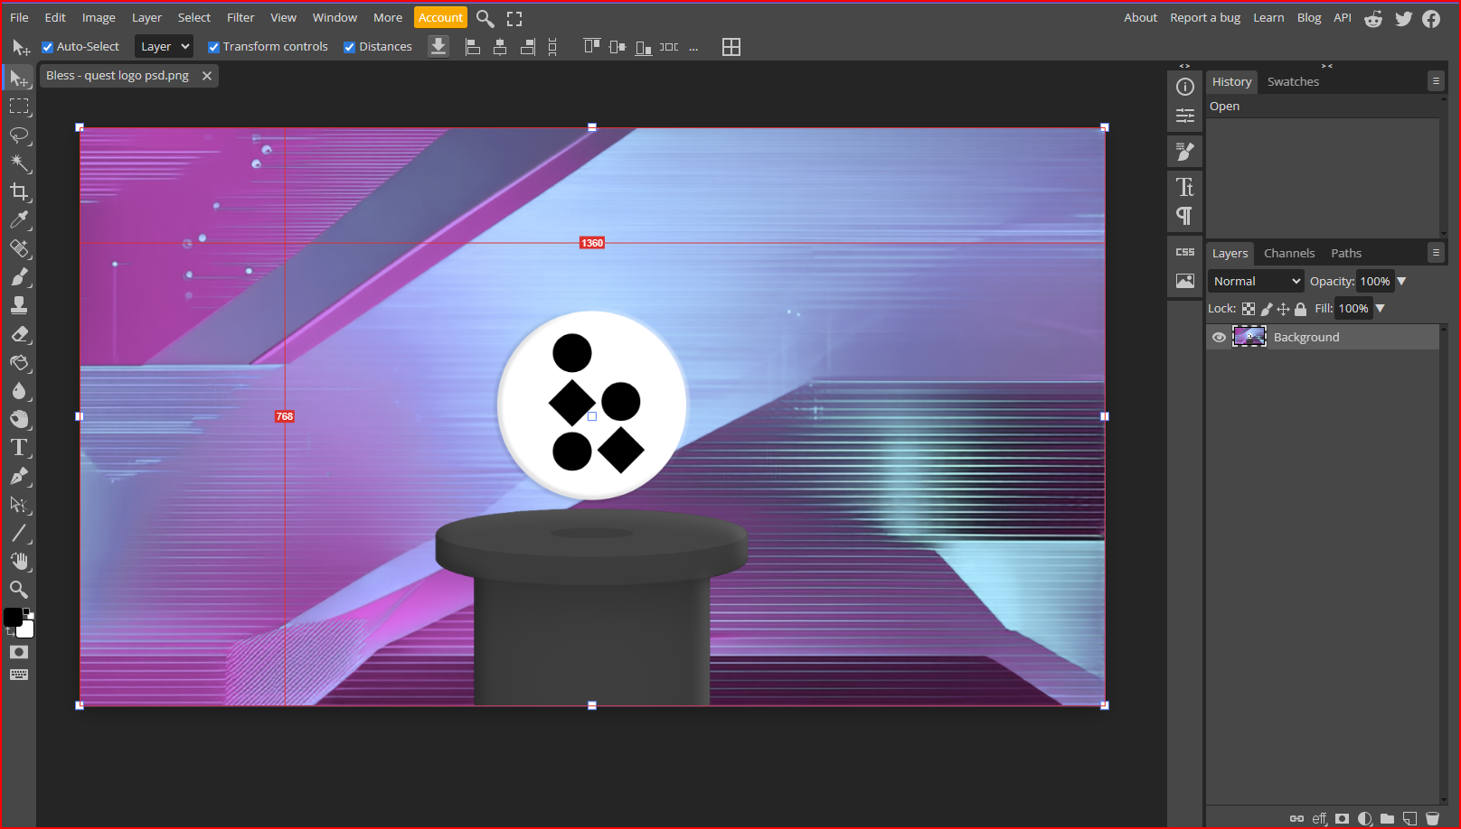

Finally, export and upload to the quest platform.

Native Quest Builder
Most quests were implemented in the platform’s builder, especially Layer3.

Layer3 has excellent documentation and support in the builder activation documentation.
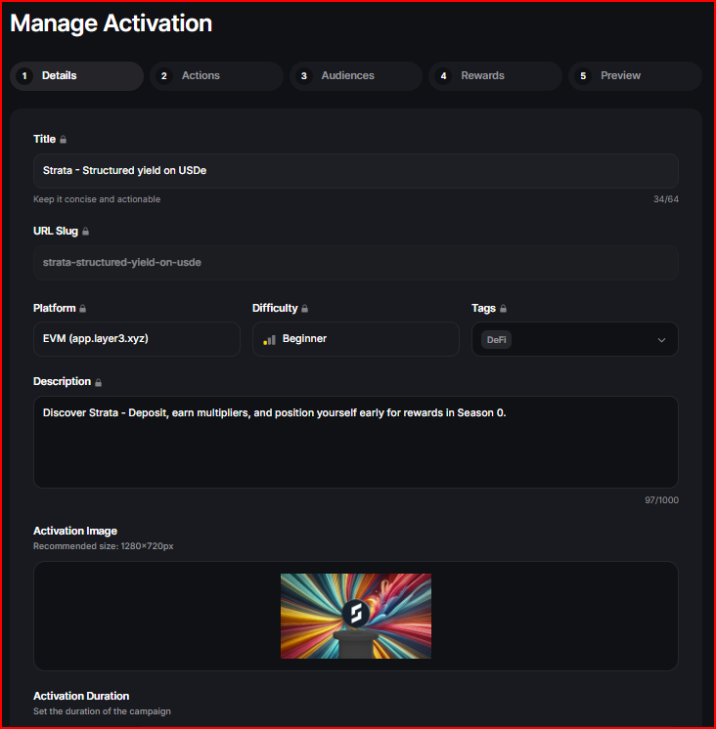

Builder focus:
- Core Quest Details - Quest name, description and URL structure
- Chain Selection - Solana vs EVM
- Card sequencing - Info cards:
  - About the Project / Protocol
  - About the quest
  - Potential rewards
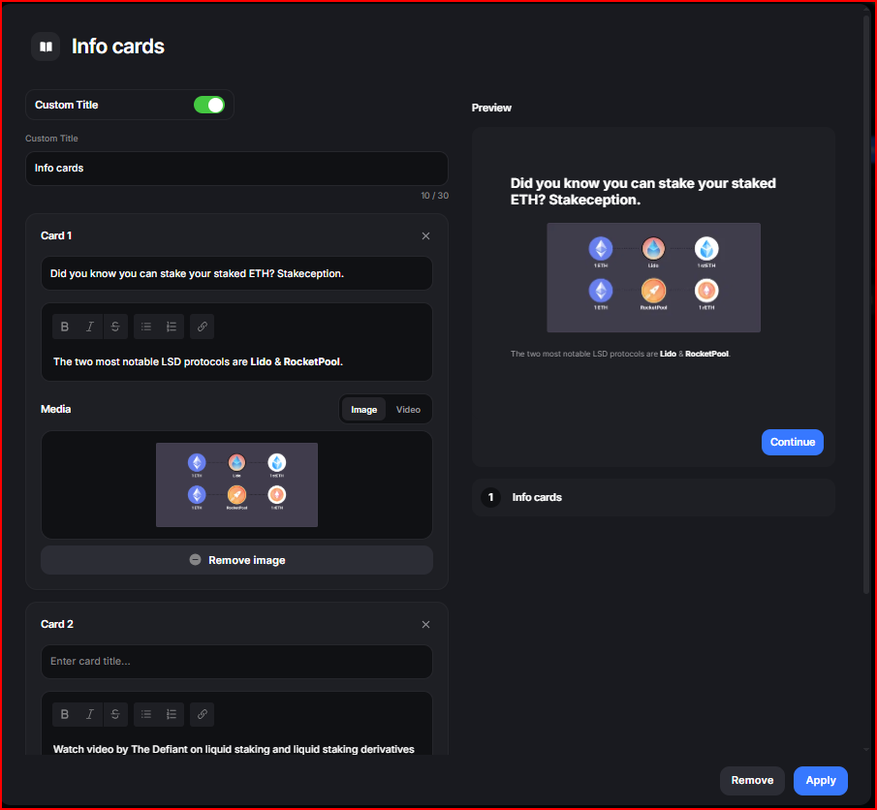

- Onchain Activity
  - Chain Selection
  - Smart contract Identification
  - Testing / Transaction Validation
  - Validation Details - Time, Minimum Amount, Specific Token, etc
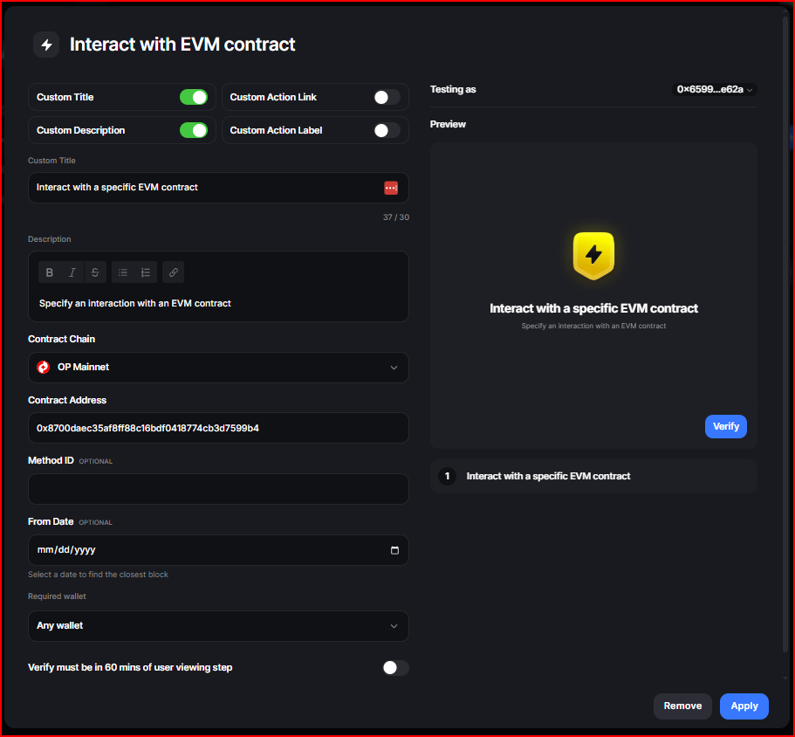

- Off-chain activity
  - Open Link (View Website, Video, Blog, Post)
  - Join Community
  - Like, Comment, and Retweet
  - Follow on X

Resources
- Quest Draft - Google Doc (Specific to this quest)
- Preview Image - PNG with Company Logo and background
- Links - Referral, SoMe, Community, Documentation, Etc
- Screenshots - Steps, Actions, Platform, etc
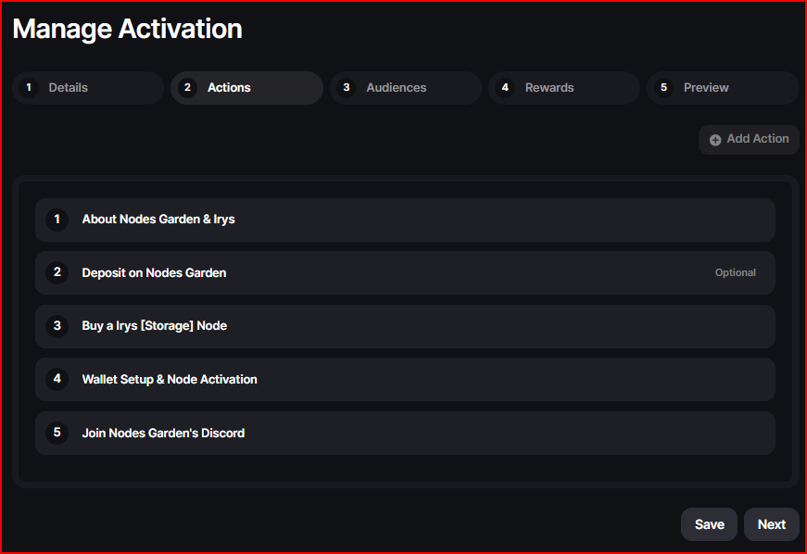

Review Checklist
- Flow - Does it make sense and work
- Link review - Referral link, SoMe Or Community
- Wordsmithing and format adjustments

The goal was always the same: keep users moving, keep proof clean.

Submit For Approval
After completion of the quest inside of the builder, I submit it inside of the platform.

Sometimes I would publish multiple quests in the same day.

Using a telegram group, I write to a few moderators and ask for feedback.
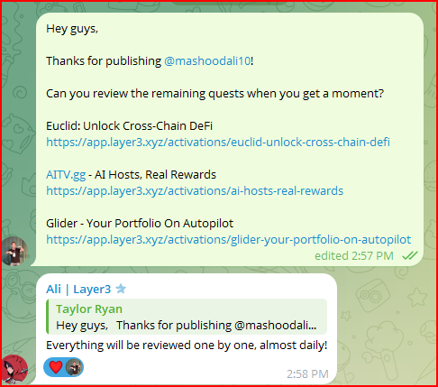

The moderators would review the quest and sometimes provide feedback.

Feedback would almost always be minor and the quest would go live within 1-2 business days.

Promotion:
After the quest was published on layer3, I would amplify the reach of the quest by doing the following:
- Post the Quest on my own X
  - Tag the Project
  - DM the Channel and Team (if possible)
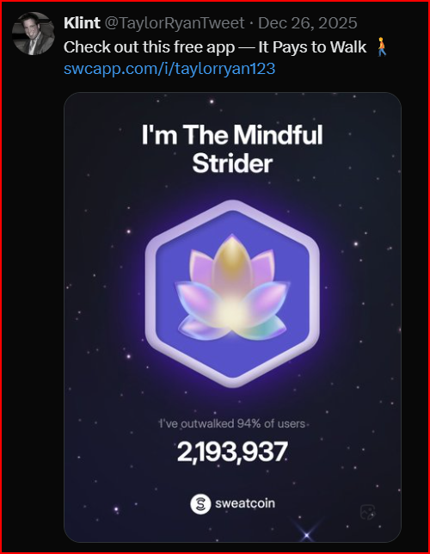

- Join the Community (Discord or Telegram)
  - Post in a general channel asking if people from the community had seen it yet
  - Create a ticket and ask the moderators to post about it.

Resources
- Prompt - Quest Promotion - Prompt - Quest Promotion - Portfolio
- Prompt - Quest Promotion - Prompt - Written Posts - Quest Promotion - Portfolio

Monitoring
On-occasion, I’ll check back on the project to see
- How my referral earnings are going
- Project developments
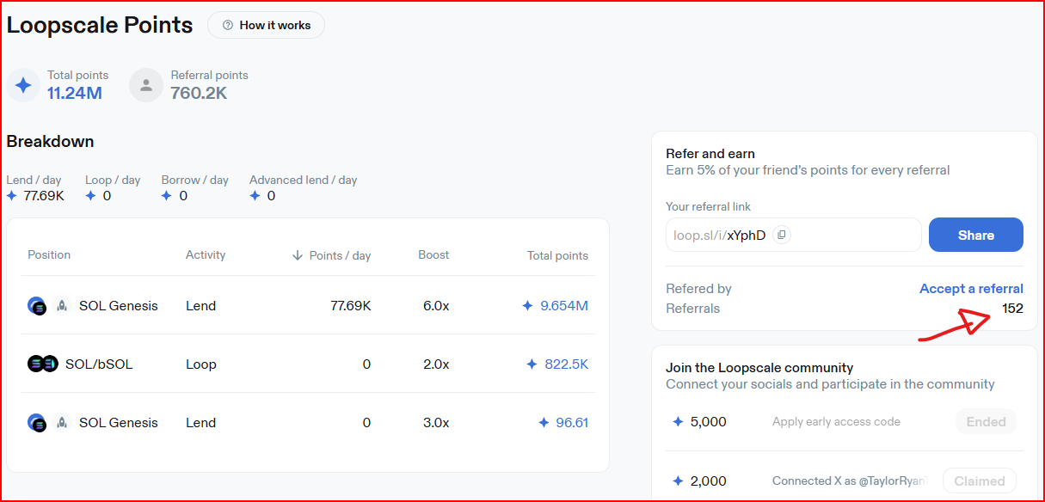

Conclusion
The 111K+ activations did not come from guesswork.

They came from a launch system designed to remove friction, protect proof quality, and make completion feel obvious.

In many cases I would receive points every time someone clicked through a quest link and signed up.

Additionally, Layer3 gave me kickbacks for publishing quests.

Sometimes the projects might give me a small kickback for my trouble.

Layer3 had a very active community and anyone could publish quests
- 39 of my quests went live on Layer3
- More than 111,000 activations in total
- 2500 - 3500 activations per quest
- Generated $32K in Rewards

My Repeatable Quest Launch System
- Project Discovery - Strong fit shortlist - Meaningful first use
- Project Enrichment - Full research pack - Test like a user
- Referral Setup - Trackable referral link - Verify with second wallet
- Functional Testing - Confirmed working flow - Minimum viable transaction
- Quest Doc Build - Clear card-by-card steps - Zero ambiguity wording
- Preview Image - Consistent quest creative - Clean template system
- Builder Implementation - Verified tasks live - Chain and contract checks
- Review and Approval - Quest goes live - Fast feedback loop
- Promotion - Distribution in community - High-intent visibility

What clients and teams get from this approach
- Faster onboarding - First to value
- Stronger verification - Fewer farmers
- Better completion - Clarity
- Campaigns built - Real usage
- Launch process - Scalable

If you want onboarding that feels crisp, measurable, and genuinely useful to users, quests are one of the best tools Web3 has.

The difference is execution. That’s the part I’ve systematized.

